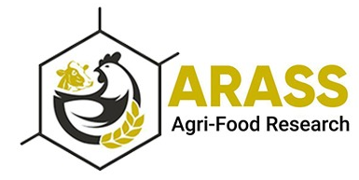

Date: 03 February, 2021

Ref. #: 20210125

**LETTER OF COLLABORATION**

It is great pleasure for me in writing this letter of collaboration for the project entitled **“Determination of multi-mycotoxin contamination levels in Total Mixed Rations (TMR) of dairy farms in Pakistan”**. I, the undersigned, confirm on behalf of Agri-Food Research & Sustainable Solutions (Private) Limited (ARASS), our interest in collaborating in this project with Department of Animal Sciences, University of Veterinary and Animal Sciences (UVAS), Lahore sub-campus Jhang. We believe that the Principal Coordinator (PI) of the project, **Dr. Mubarik Mahmood**, Lecturer Animal Nutrition in the same department has potential to execute the project activities. ARASS principally agrees to contribute the project by providing financial support related to sample collection and shipment to Austria. Additionally, the undersigned will be providing technical guidance during the whole project which will be completed in one year duration from March 2021 to March 2022.

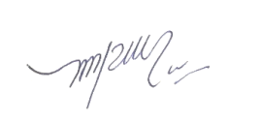

Warm Regards,

Dr. Muhammad Zafar Ullah Khan

PhD (Animal Nutrition)

Director, Research and Development

**AGRI-FOOD RESEARCH & SUSTAINABLE SOLUTIONS (PRIVATE) LIMITED (ARASS)**

F-1, IBL Market, Ghouri Block, Bahria Town, Lahore (54000).

+92.333.4754251. info@arass.org